Patrick Snell, Brad Bayuga

COMP 3700

Course Project Iteration 1 – Implementation/Testing

**Task 1 Implementation**

Please see the running version on GitHub which implements the three use cases: 1) Checkout 2) Add a new product 3) Update an existing product

**NOTE: Some of the code in the running version was taken from Dr. Nguyen’s demo on canvas. We do not claim this code used from the demo to be our own.**

**Task 2 Testing**

1) Checkout

By testing the Checkout use case, a user would type in the barcode number and the quantity. The following test is below, which shows what occurs when valid values are entered. First, observe the Product Table from the Store Management System database.

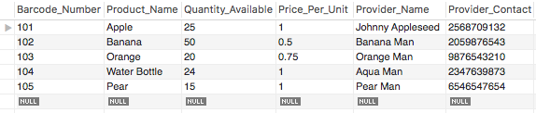

Now when the system runs, the Store Management System main screen appears. After selecting Checkout, the Checkout screen appears.

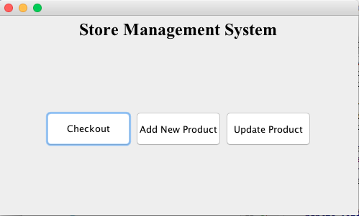

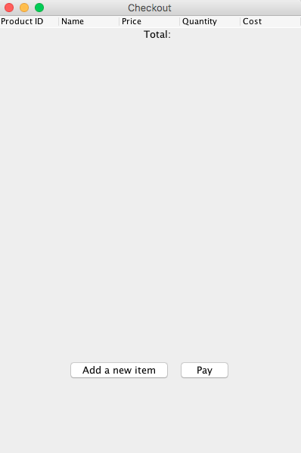

After selecting “Add a new item”, the user must type in a valid barcode number and quantity.

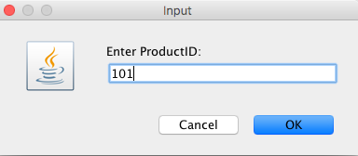

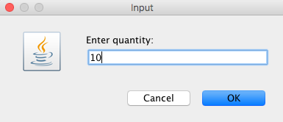

As can be seen, Apple is updated on the screen and the Product Table from the Store Management System database is updated as well.

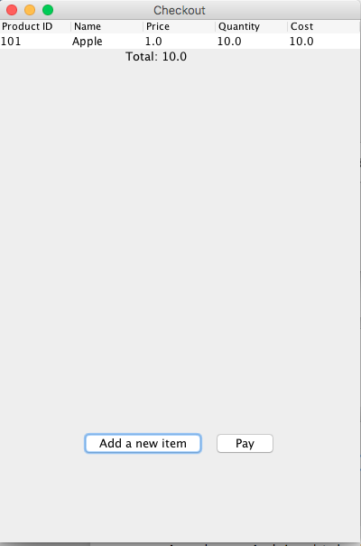

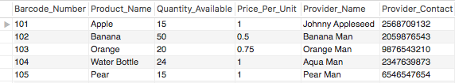

2) Add A New Product

This tests adding a new product. First observe the current Product table.

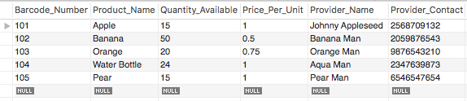

Now a user adds a new product:

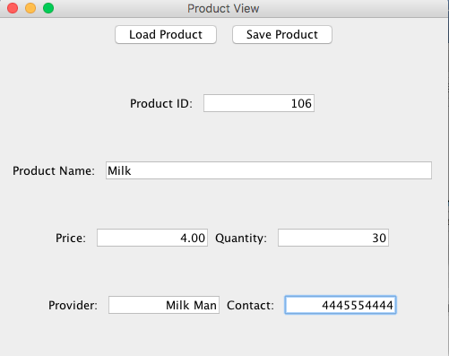

After the user selects “Save”, the new product is saved. This is reflected in the Product table seen here.

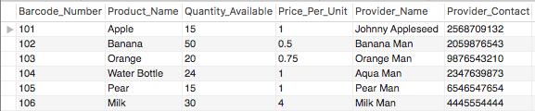

3) Update A Product

This tests adding updating an existing product. First observe the current Product table.



Now when a user loads in the product and updates it, these updates should be reflected in the database.

